Kafka Integration with C#:
Outline:
- Introduction to Kafka
- Kafka Architecture
- Topics
- Partitions
- Brokers
- Kafka plug in .NET
- Installation of Kafka
- Basics of Zookeeper
- Demo

Hands On:

- Create a Chat Application which uses Kafka as a streaming platform and consume the chat messages in the command prompt.

- Create a Chat Application using C# Windows Application using Kafka and consume the message in different client applications.

Reference Links:
- https://www.c-sharpcorner.com/article/apache-kafka-net-application/
- https://www.c-sharpcorner.com/article/step-by-step-installation-and-configuration-guide-of-apache-kafka-on-windows-ope/

Demo output:

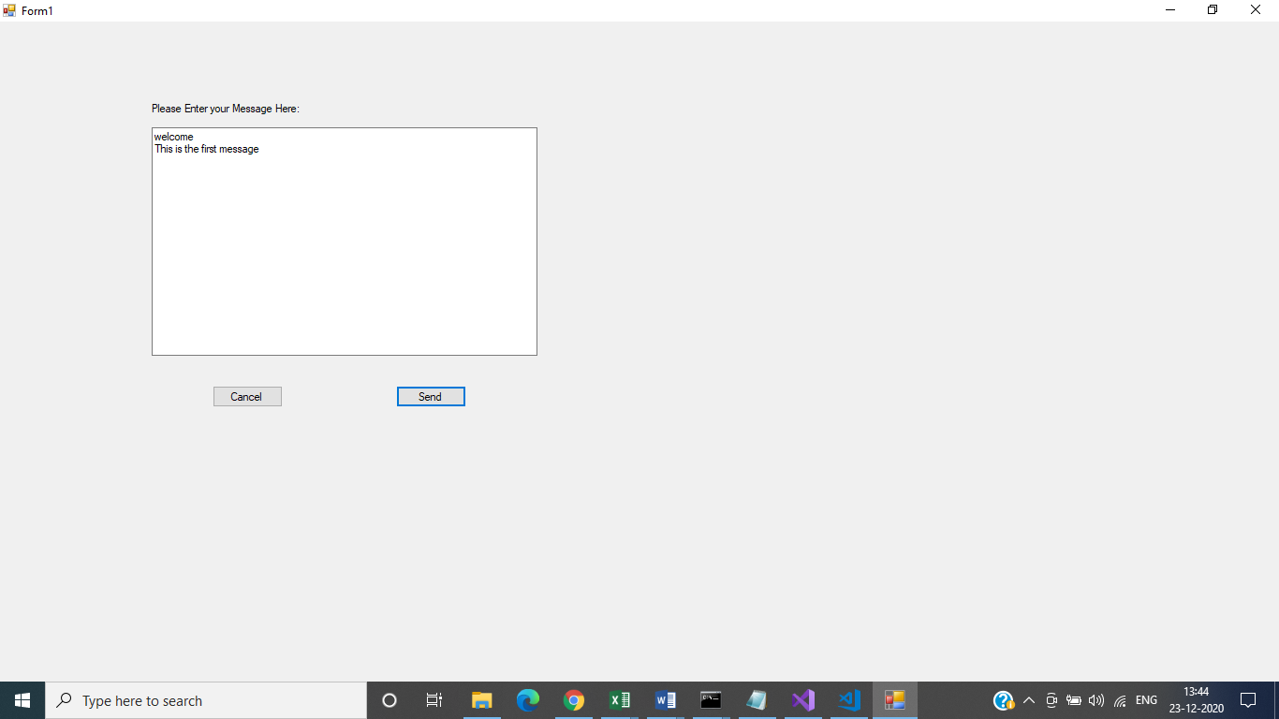

Kafka Server Running:
Kafka-server-start.bat ../../config/server.properties
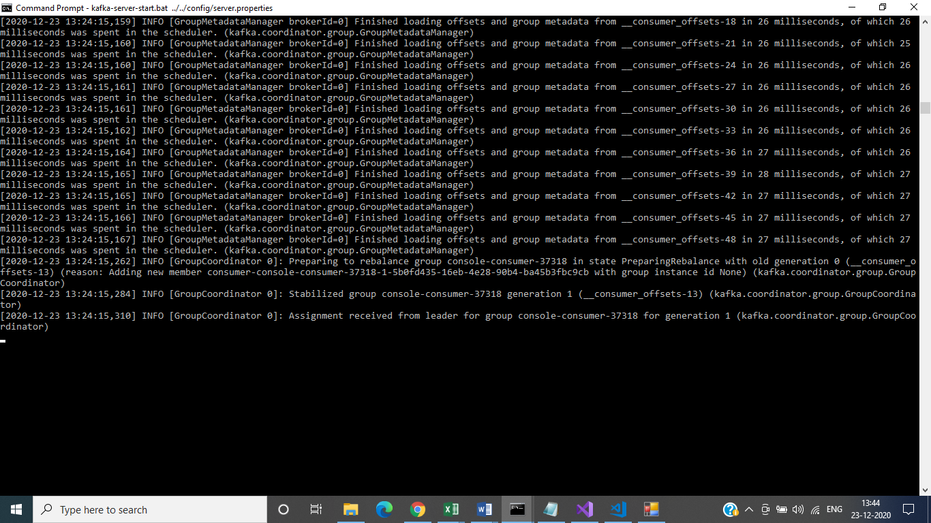

Zookeeper Running:
Zookeeper-server-start.bat ../../config/zookeeper.properties
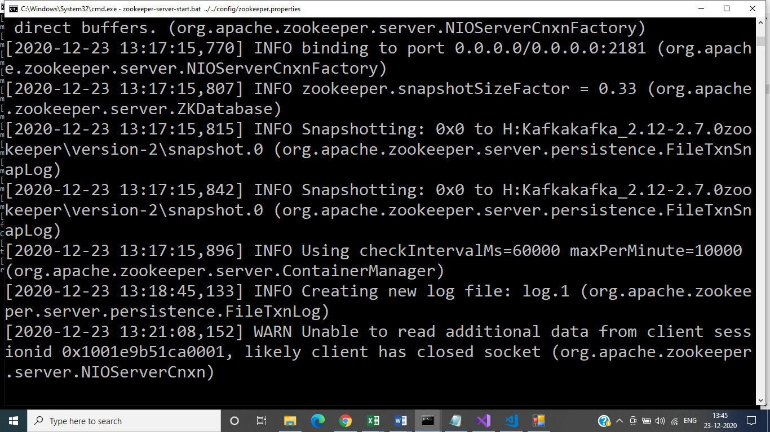

Topic Created:
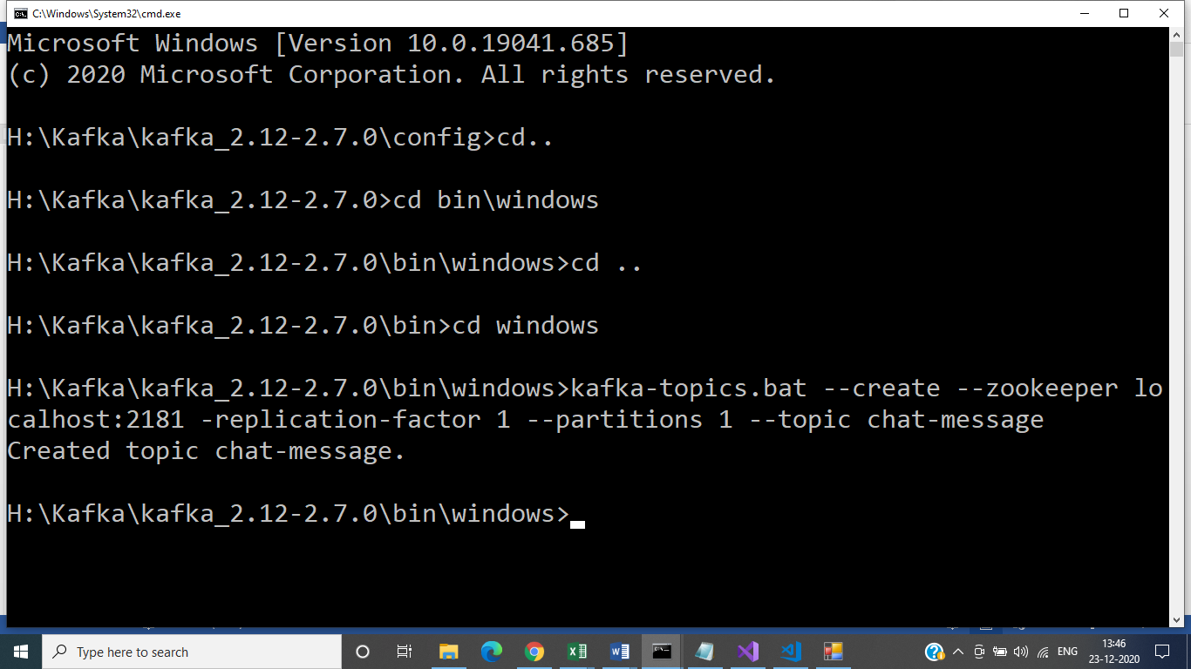

Creating Publisher in Command Prompt:
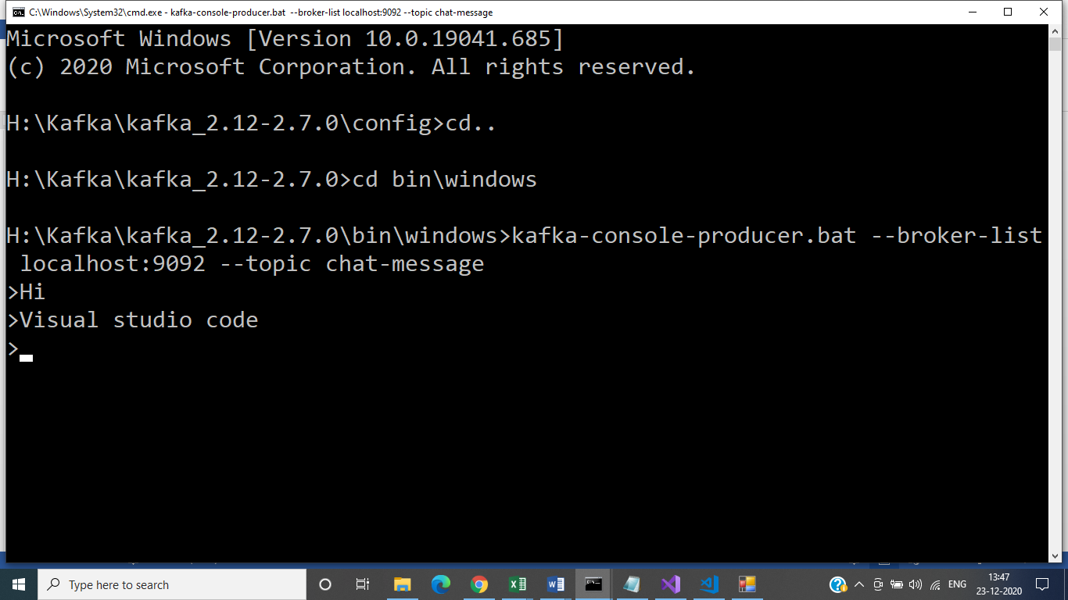

Client Application:
